Reference Standards
# Source: AI Source: Provided by: [Data Path: Persons Table -> ID Column: 1, Name_En Column: Motasem Essam] -> From: [ChatGPT] on [7/17/2026]
Reference Standards are measurement standards of the highest metrological quality available within a particular laboratory, organization, or calibration facility. They are used as the principal reference for calibrating working standards and verifying measurement accuracy within that organization.
Unlike primary standards, which are maintained by national metrology institutes, reference standards are maintained by individual laboratories or organizations and are calibrated against primary or secondary standards to ensure traceability.

Definition
# Source: AI Source: Provided by: [Data Path: Persons Table -> ID Column: 1, Name_En Column: Motasem Essam] -> From: [ChatGPT] on [7/17/2026]
A Reference Standard is a measurement standard designated as the best available standard within a laboratory or organization and used as the reference for calibrating other standards and measuring instruments.
Its measurement value is obtained through calibration against a primary or secondary standard.

Purpose
# Source: AI Source: Provided by: [Data Path: Persons Table -> ID Column: 1, Name_En Column: Motasem Essam] -> From: [ChatGPT] on [7/17/2026]
Reference standards are used to:
- Calibrate working standards.
- Verify measurement accuracy.
- Maintain laboratory measurement consistency.
- Provide traceability to higher-level standards.
- Support quality assurance.
- Reduce the direct use of higher-level standards.

Characteristics
# Source: AI Source: Provided by: [Data Path: Persons Table -> ID Column: 1, Name_En Column: Motasem Essam] -> From: [ChatGPT] on [7/17/2026]
Reference standards are:
- Highly accurate.
- The best standards available within a laboratory.
- Calibrated against primary or secondary standards.
- Used regularly for laboratory calibration.
- Maintained under controlled environmental conditions.
- Periodically recalibrated.

Position in the Measurement Hierarchy
# Source: AI Source: Provided by: [Data Path: Persons Table -> ID Column: 1, Name_En Column: Motasem Essam] -> From: [ChatGPT] on [7/17/2026]
Reference standards occupy the fourth level in the measurement hierarchy.
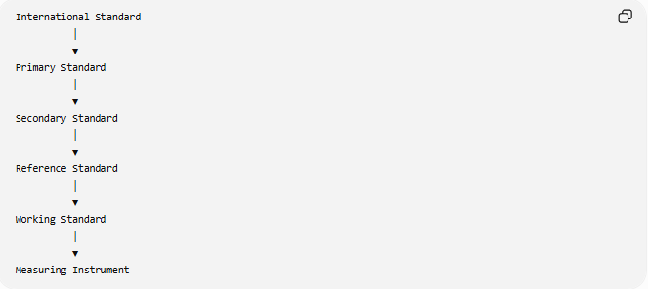
International Standard
│
▼
Primary Standard
│
▼
Secondary Standard
│
▼
Reference Standard
│
▼
Working Standard
│
▼
Measuring Instrument

How Reference Standards Are Established
# Source: AI Source: Provided by: [Data Path: Persons Table -> ID Column: 1, Name_En Column: Motasem Essam] -> From: [ChatGPT] on [7/17/2026]
A reference standard is created by calibration against a higher-level standard.
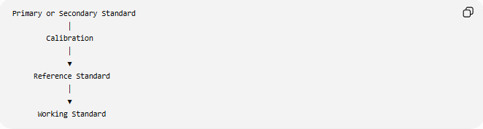
Primary or Secondary Standard
│
Calibration
│
▼
Reference Standard
│
▼
Working Standard

Functions of Reference Standards
# Source: AI Source: Provided by: [Data Path: Persons Table -> ID Column: 1, Name_En Column: Motasem Essam] -> From: [ChatGPT] on [7/17/2026]
Reference standards are used to:
- Calibrate working standards.
- Verify laboratory measuring instruments.
- Maintain traceability.
- Monitor measurement quality.
- Support accreditation requirements.
- Ensure consistency of laboratory measurements.

Examples of Reference Standards
# Source: AI Source: Provided by: [Data Path: Persons Table -> ID Column: 1, Name_En Column: Motasem Essam] -> From: [ChatGPT] on [7/17/2026]
Length
A laboratory-grade gauge block set calibrated against a secondary length standard.

Mass
A certified precision calibration weight used as the laboratory's reference for calibrating other weights.

Time
A precision laboratory clock synchronized with a national time standard.

Temperature
A certified platinum resistance thermometer used as the laboratory reference.

Pressure
A high-accuracy pressure calibrator used as the laboratory reference standard.

Electrical Measurements
- Precision voltage reference.
- Precision resistance standard.
- Precision current reference.
Each is calibrated against a higher-level standard.

Traceability
# Source: AI Source: Provided by: [Data Path: Persons Table -> ID Column: 1, Name_En Column: Motasem Essam] -> From: [ChatGPT] on [7/17/2026]
Reference standards maintain measurement traceability by linking working standards to higher-level standards.
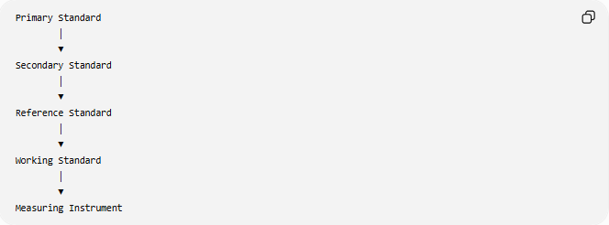
Primary Standard
│
▼
Secondary Standard
│
▼
Reference Standard
│
▼
Working Standard
│
▼
Measuring Instrument

Calibration
# Source: AI Source: Provided by: [Data Path: Persons Table -> ID Column: 1, Name_En Column: Motasem Essam] -> From: [ChatGPT] on [7/17/2026]
Reference standards require regular calibration.
Typical calibration process:
- Compare the reference standard with a secondary or primary standard.
- Determine measurement error.
- Adjust or certify the reference standard if necessary.
- Record calibration results.
- Establish the next calibration interval.

Advantages
# Source: AI Source: Provided by: [Data Path: Persons Table -> ID Column: 1, Name_En Column: Motasem Essam] -> From: [ChatGPT] on [7/17/2026]
Reference standards:
- Provide excellent measurement accuracy.
- Support laboratory calibration.
- Maintain traceability.
- Improve quality assurance.
- Protect higher-level standards from excessive use.
- Support accreditation and compliance.

Applications
# Source: AI Source: Provided by: [Data Path: Persons Table -> ID Column: 1, Name_En Column: Motasem Essam] -> From: [ChatGPT] on [7/17/2026]
Reference standards are commonly used in:
- Calibration laboratories.
- Industrial quality control.
- Manufacturing.
- Engineering.
- Scientific research.
- Medical laboratories.
- Testing laboratories.
- Universities.
- Aerospace.
- Electronics.

Everyday Importance
# Source: AI Source: Provided by: [Data Path: Persons Table -> ID Column: 1, Name_En Column: Motasem Essam] -> From: [ChatGPT] on [7/17/2026]
Although rarely seen by the public, reference standards help ensure:
- Accurate laboratory testing.
- Reliable weighing scales.
- Correct medical equipment calibration.
- Precision manufacturing.
- Consistent product quality.
- Accurate industrial measurements.

Common Mistakes
# Source: AI Source: Provided by: [Data Path: Persons Table -> ID Column: 1, Name_En Column: Motasem Essam] -> From: [ChatGPT] on [7/17/2026]
- Confusing reference standards with secondary standards.
- Assuming every laboratory has a primary standard.
- Using reference standards for routine daily measurements instead of working standards.
- Neglecting periodic recalibration.

Key Points
# Source: AI Source: Provided by: [Data Path: Persons Table -> ID Column: 1, Name_En Column: Motasem Essam] -> From: [ChatGPT] on [7/17/2026]
- Reference standards are the highest-quality standards within a laboratory or organization.
- They are calibrated against primary or secondary standards.
- They are used to calibrate working standards.
- They maintain laboratory measurement traceability.
- They are periodically recalibrated to preserve accuracy.

Reference Standards vs. Secondary Standards
# Source: AI Source: Provided by: [Data Path: Persons Table -> ID Column: 1, Name_En Column: Motasem Essam] -> From: [ChatGPT] on [7/17/2026]
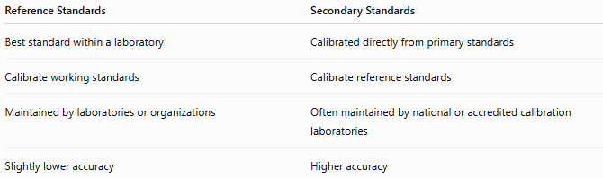
Reference Standards | Secondary Standards
Best standard within a laboratory | Calibrated directly from primary standards
Calibrate working standards | Calibrate reference standards
Maintained by laboratories or organizations | Often maintained by national or accredited calibration laboratories
Slightly lower accuracy | Higher accuracy

Reference Standards vs. Working Standards
# Source: AI Source: Provided by: [Data Path: Persons Table -> ID Column: 1, Name_En Column: Motasem Essam] -> From: [ChatGPT] on [7/17/2026]
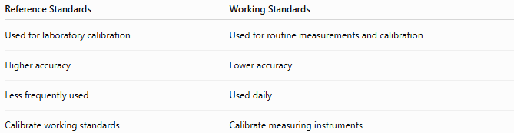
Reference Standards | Working Standards
Used for laboratory calibration | Used for routine measurements and calibration
Higher accuracy | Lower accuracy
Less frequently used | Used daily
Calibrate working standards | Calibrate measuring instruments

Reference Standards vs. Primary Standards
# Source: AI Source: Provided by: [Data Path: Persons Table -> ID Column: 1, Name_En Column: Motasem Essam] -> From: [ChatGPT] on [7/17/2026]
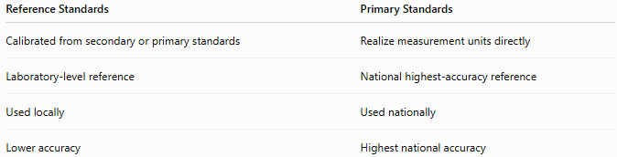
Reference Standards | Primary Standards
Calibrated from secondary or primary standards | Realize measurement units directly
Laboratory-level reference | National highest-accuracy reference
Used locally | Used nationally
Lower accuracy | Highest national accuracy

Conclusion
# Source: AI Source: Provided by: [Data Path: Persons Table -> ID Column: 1, Name_En Column: Motasem Essam] -> From: [ChatGPT] on [7/17/2026]
Reference Standards are the highest-quality measurement standards available within a laboratory or organization. Calibrated against primary or secondary standards, they provide the local reference for calibrating working standards and maintaining measurement traceability. By ensuring accurate and consistent laboratory measurements, reference standards play a vital role in quality assurance, scientific research, industrial calibration, manufacturing, and testing while preserving the accuracy of higher-level standards through reduced direct use.

